Video Game Characters with Mental Illness
Race and Gender may be the hot topics, but I want to talk about a different form of representation in games.
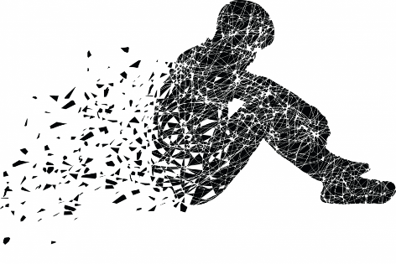

When writing a character, most designers follow the hero’s journey framework – a warrior protagonist who fights a great evil.
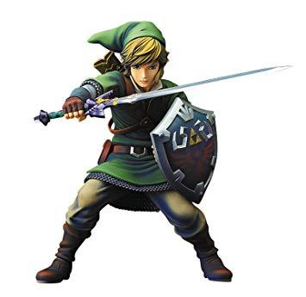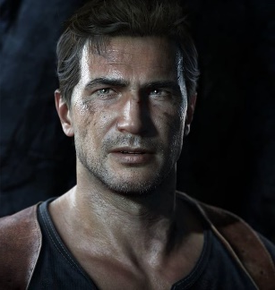

I want to talk about different kinds of warriors who fight a different type of battle. Let’s take a look at some good examples of mental illness in video games.

Before continuing, I need to give a SPOILER ALERT. If you intend on playing the following games, please stop reading:

Henry and Julia - Firewatch
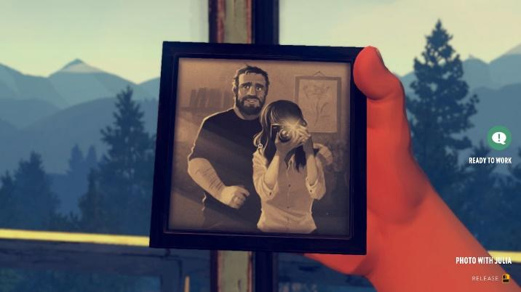
At the beginning of Firewatch, it is revealed that the reason why protagonist Henry took on the role of park ranger was to get away from his old life. His wife Julia suffers from onset Dementia and had to be taken away to Australia to receive special treatment. Henry’s true feelings about the situation are revealed through in game narrative – broken dreams, sexual repression, and hopelessness are all common themes in his life. He may not be your typical hero, but his story accurately represents what Dementia can do to a relationship.

Mae Borowski – Night In The Woods
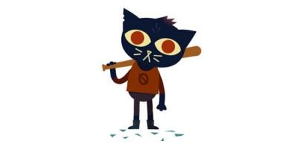
The game begins with Mae returning to her hometown of Possum Springs after dropping out of college. Most of the game is spent exploring the town and talking with locals, however, there are dreamlike segments where Mae enters a hallucinogenic state. Eventually it is revealed that she suffers from a Dissociative Disorder. During one of her dissociations at school, she bludgeoned a student with a baseball bat (which was the reason why she dropped out). You would think that a person who commits such violence in a game like this was a monster, The game excellently humanizes her as a young girl with deteriorating mental health.

Quinco – Post Traumatic Stress Dissorder
